SQL Project

Problem Statement:
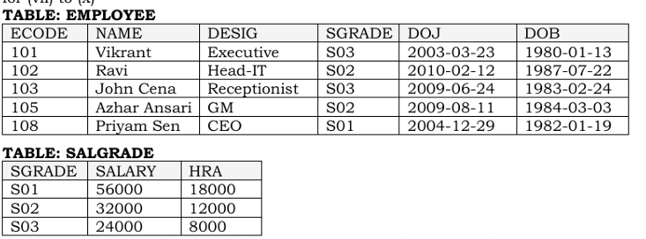

Create Database and Table:
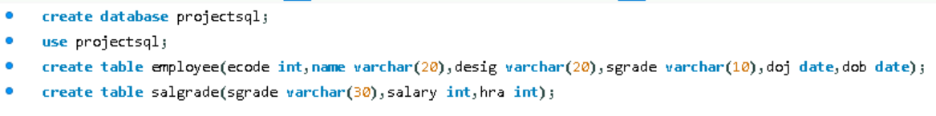

Insert Values:
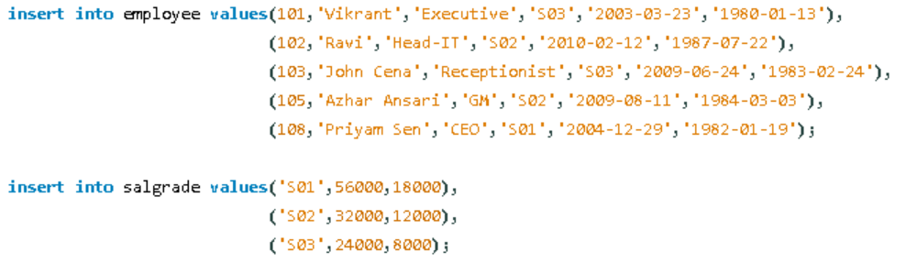

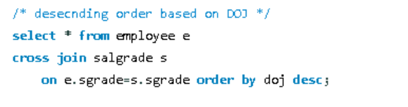
Output:
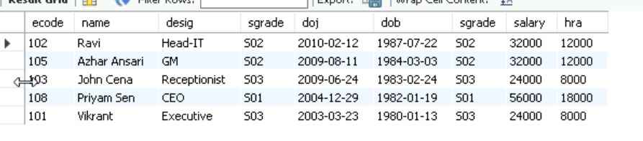

Output:
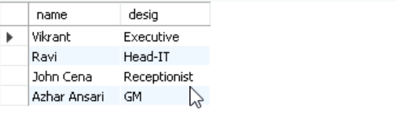

Output:
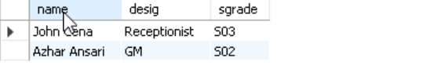

Output:
